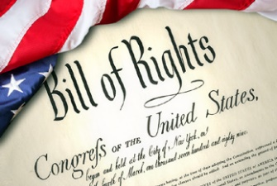
Bill of Rights Project Calendar

Dec. 5 | 6  By this date, your research for questions 1-3 should be done. | 7  By this date, question 1 should be answered. | 8  By this date, question 2 should be answered. | 9  By this date, question 3 should be answered.
12 | 13  By this date, you should have your Students’ Bill of Rights planned. | 14 | 15  By this date, you should have your Students’ Bill of Rights revised and edited. Please begin to publish. | 16
19  You should be halfway (or more) through publishing your Students’ Bill of Rights. | 20 | 21  You project is due today. Please pass it in with the project packet.  Happy Holidays!

