Welcome to Mr. Davey’s Social Studies Class!
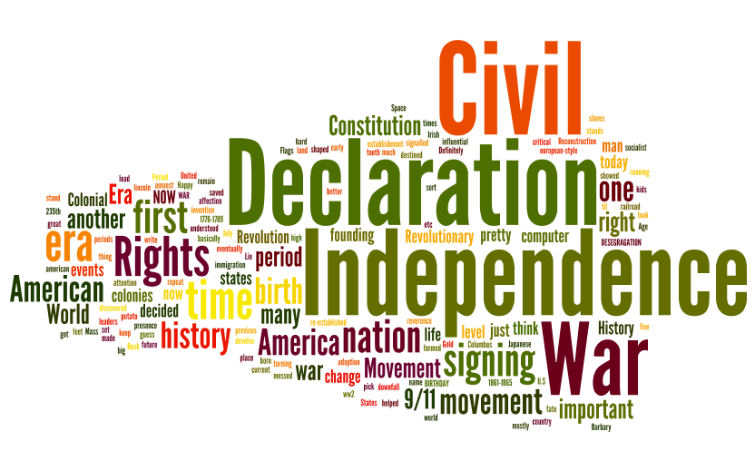
Grade 7 Room C223

Welcome to our team! This year, Mr. Davey will be your guide through American history from the French and Indian War to the end of the American Civil War.
History is not just memorizing dates, places, and people. It’s learning about the political, economic, and geographical twists and turns that created, grew, and sustained our country from the mid 1700’s to the mid 1800’s. It’s about learning WHY things happened the way they did- and examining the many sides of the important issues that changed history.
This class is also about learning to read and write critically. Students will be asked to read a variety of primary and secondary sources that will help them learn about the significance of historical events. They will also be asked to answer questions regarding the events and people we learn about as well as to support their answers with evidence and explanation. The program of studies in this class reflects the Connecticut Common Core of Learning and National Standards.

Classroom Expectations: Expectations in our classroom are fairly simple. In addition to exemplifying the Core Values of our school, students will be expected to DO THEIR BEST each day.
Doing your best means:
Be prepared.
Be honest.
Be willing to work constructively with your classmates.
Be enthusiastic.
Be willing to appreciate others’ opinions.
Be willing to work hard- even when you may become frustrated.
Treat your classmates and teachers with respect.

Major Units of Study This School Year:
Causes of the American Revolution (1763-1775)
The American Revolution (1775-1783)
Creating a Republic and the Constitution (1783-1800)
Growth and Expansion (1790-1825)
The Industrial Revolution (1790-1840)
The Jacksonian Era and Significance (1824-1830)
Westward Expansion (1820-1860)
Reform Movements and Social Change (1820-1860)
Road to the Civil War (Life in the North and the South) (1820-1860)
The Civil War (1861-1865)

Grading Policy: Grades are assigned a number of points. Your grade for each trimester will be calculated through three categories. Classwork and homework assignments count for 10% of your overall grade. Formative assessments, quizzes and minor projects, will constitute 40% of the overall marking period grade. Summative assessments, such as tests and major projects, will make up 50% of your final grade.
Homework/Classwork- 10%
Quizzes/Minor Projects- 40%
Tests/Major Projects- 50%
*Minor and major projects include written responses that can be one or more paragraph(s).
Homework and class work are expected to be completed on time (unless there is a signed note from a parent or care giver explaining a sickness/family emergency/etc.- in which case, an extension will be allowed). If you do not complete homework or classwork assignment on time- or you need to make up some note taking or other class assignment- you may complete it during a working lunch or an in-school or after-school time arranged by Mr. Davey. Any assignment or project that is not turned in on time will be entered as a zero for a grade (in Powerschool) until it is turned in to Mr. Davey. Remember, it is your responsibility to take the initiative to want to make up work not completed on time.
If you earn a 70% or below on a test or major project, you will be given an opportunity to complete an alternate assignment or assessment to demonstrate your understanding of the material assessed. Prior to your alternate assignment, you will be required to complete (and have signed by a parent as well as student) an action plan outlining how you choose to master the material assessed. You may be able to add points to your original grade if your additional work shows a mastery of the concepts assessed.
Communication and Contact: For most assignments and projects, students will be provided specific directions, models, and rubrics/grading sheets to guide them through their completion.
For quizzes and tests, students will be provided with materials to help them to prepare to succeed. Rather than use the word study, our class will focus on strategies and ways to prepare to succeed.
In addition to giving the above-listed materials to students in class, most will be loaded onto Mr. Davey’s web page. The web page will also include an assignment/reminder calendar (updated daily), contact information, and other documents associated with our classroom. The web page can be accessed through our district’s web site.
Each week, there will be an email sent home (through Powerschool) to all parents and/or care givers of students that outlines the learning of the week, reminders about assignments/projects/tests, and other information.
If students or parents/care givers have any questions about our class, they are always welcome to send me an email (through the district web site or directly- rdavey@rsd17.org) or call the school.

I’m looking forward to a great year of learning! I hope you are, too!
Mr. Davey

Please sign and return to Mr. Davey. This is your first graded homework assignment.

I have read and understand the expectations for Social Studies with Mr. Davey this school year.

Student’s Name:

Parent/Care Giver Signature:

Student Signature:

