Name _________________________________________ Period _______
“Most Important Invention or Innovation” Grading Sheet
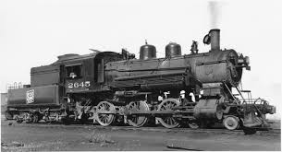

Item Possible Points Your Score Teacher’s Score

Completed on Time 5 _________ ____________

You graded yourself. 5 _________ ___________

Research is complete. 15 _________ ___________

Notes are complete and organized. 15 _________ ____________

Appropriate Title 5 ________ ____________

The Quality of your Response 15 _________ ____________

Total 60 _________ ____________

Student’s Comments:

Teacher’s Comments:
What You Did Well Way(s) to Improve Your Next Response

Name _________________________________________________ Period ____
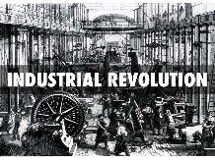
The Industrial Revolution

Most Important Invention or Innovation Response
Your task for this project is to research, take notes, and write about the invention or innovation you think was the important of the Industrial Revolution. Answer this question:
What was the most important invention or innovation of the Industrial Revolution?
Step 1: Research- Using resources provided in school and ones you find and read/watch yourself, spend time becoming an “expert” on your topic. Be sure to choose resources that you understand easily and have a lot of useful information on your topic.

Step 2: Take Notes- Use two column or boxes and bullets to take specific, organized notes. You may want to use subtitles in your notes. For example, if your topic was Interchangeable Parts, you may use these subtitles:
1. What are interchangeable parts? How do they work? Who invented the process?
2. How did using interchangeable parts improve manufacturing products?
3. How did interchangeable parts impact the U.S.A. and world?

Step 3: Plan your Writing- Be sure to have three or more supporting reasons that PROVE your topic was the most important invention or innovation of the Industrial Revolution. You may use a boxes and bullets plan provided by Mr. Davey.

Step 4: Write- Use your plan. Please have an introduction (claim) to begin your writing. Separate your supporting reasons into paragraphs.

Step 5- Revise and Edit- Use feedback from Mr. Davey from responses to guide you.

Step 6- Publish- You may write this by hand, type a copy (with or without pictures), or create a slide show.

This project is due by __________________________________________________.

