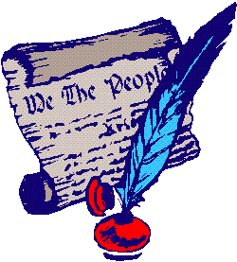
Name _____________________________________________ Period _________
The New Government
Terms and People to Know

Please identify and define these terms:
Constitution Bill of Rights Articles of Confederation checks and balances amend
Executive Branch Judicial Branch Legislative Branch unicameral bicameral
ratify 3/5 Compromise Great Compromise Shay’s Rebellion
Northwest Ordinance

Please be able to explain these ideas:
* the responsibilities and checks of each branch of our government
* the differences and similarities between the Federalists and Anti-Federalists

This is how I am going to prepare for this test:
__________________________________________________________________________________________________________
__________________________________________________________________________________________________________
__________________________________________________________________________________________________________
__________________________________________________________________________________________________________
__________________________________________________________________________________________________________

