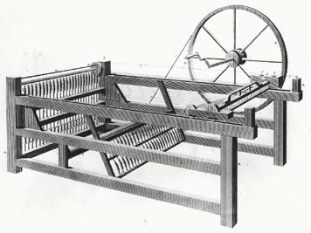
Name _______________________________________ Period ______
Most Important Invention/Innovation of the Industrial Revolution Project
Sources Used for this Project
Please list the sources (anything you used to get information/quotes about your topic) you used for this project. You must have at least 3 sources.
*For Books- Please list the title, author(s), and page(s) used.
*For Web Sites- Please list the URL address (all of it, please).
*For Magazines and Journals- Please list the title of the magazine, the volume of the magazine, the title and author of the article you used.
*For Videos- Please list the title of the video, the name of the person who posted the video, and the web site that posted the video

Source 1- _____________________________________________________________________________
_____________________________________________________________________________________
Source 2- ____________________________________________________________________________
____________________________________________________________________________________
Source 3- ____________________________________________________________________________
____________________________________________________________________________________
Source 4- ____________________________________________________________________________
____________________________________________________________________________________
Source 5- ____________________________________________________________________________
____________________________________________________________________________________

