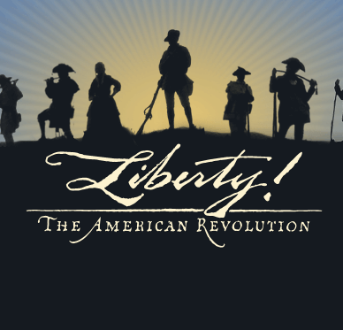
Name ____________________________________
American Revolution Test
Preparation Guide
Please use this guide to prepare for the American Revolution Test. You will need to know the significance/importance of each term or person.
Please list some ways you can practice for the test:
______________________________ _____________________________
______________________________ _____________________________
______________________________ _____________________________
Here are the terms you will need to know for the upcoming test on the American Revolution.

Second Continental Congress Battle of Bunker Hill Thomas Jefferson
John Adams Fort Ticonderoga Declaration of Independence (1776)
Battle of Trenton Battle of Saratoga Benjamin Franklin
Valley Forge Benedict Arnold General Cornwallis
Nathaniel Greene Battle of Cowpens Battle of Yorktown
British People Treaty of Paris (1783)

Here are the three possible open-response questions that may be on the test.

1. What is the difference between the Revolutionary War and the American Revolution?

2. Which one person, document, or event was the most important to understanding how the colonies gained their independence from Great Britain to become the United States of America?

3. Why and how did Great Britain lose the Revolutionary War- even though they were the most powerful military in the world at the time?

