The Steam Engine
The Invention that Triggered the Industrial Age

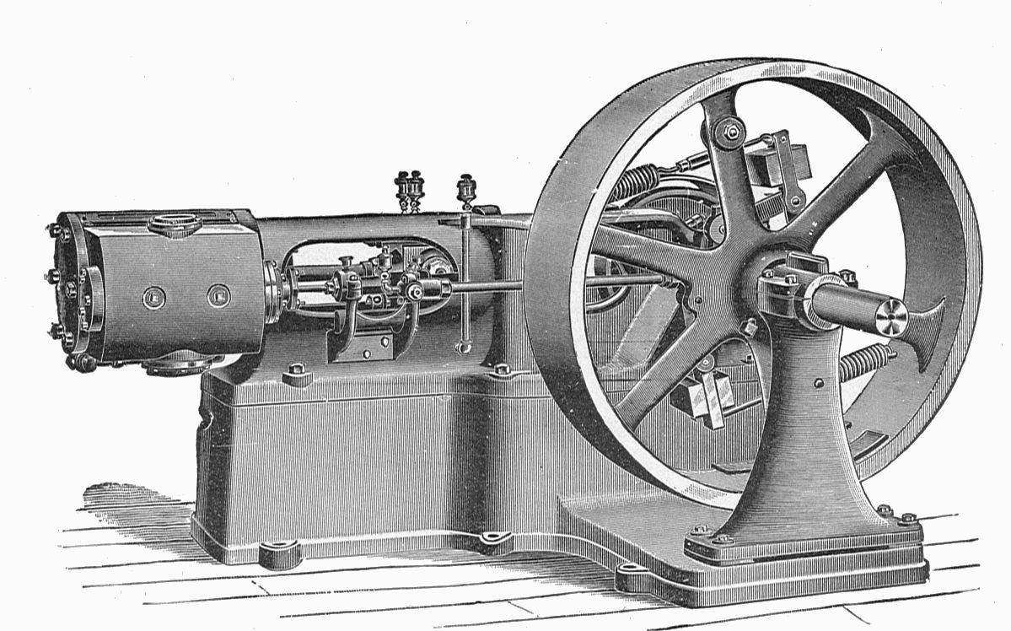

by Mr. Davey

The Beginning
Believe it or not, steam powered machines have been around since the Ancient Greeks.
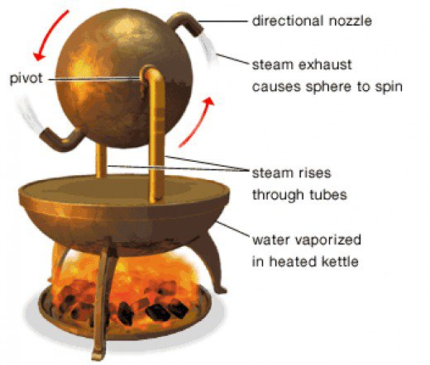

Even before the rise of the Roman Empire, people were using steam powered machines to automatically open doors and as weapons.

The Modern Steam Engine

1712- Thomas Newcomen improves
Savery’s steam engine

1790- James Watt improves earlier steam engines to create the modern steam engine.
1689- Thomas Savery invents a steam pump to remove water from mines.

How the Steam Engine Changed the World
1. Jobs that took people a lot of time and hard labor, like manufacturing things, would now be easier to make and more efficient to do.
2. The steam engine began the Industrial Revolution in the early 1800’s. This movement changed much of the world from farming to industrial.
3. Many people moved from rural (country) to urban (city) places to get jobs in factories.
4. Since manufacturing was easier and less “back-breaking” than before the steam engine, children began to work in factories.
5. Many cities were established and other cities grew quickly- especially near waterways.
6. Transportation by railroads and ships became much more efficient. People and products could move from place to place much more quickly than before locomotives and steam-powered ships.

Why YOU Should Care About the
Steam Engine!

The steam engine had a profound and essential effect on the world in the 1800’s, 1900’s, and…
*Making Textiles

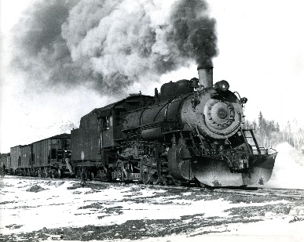
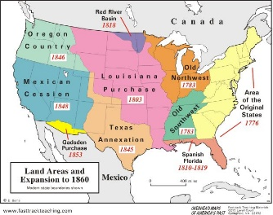
*Opening Up the Western U.S.A.

*Transporting Stuff Around the World
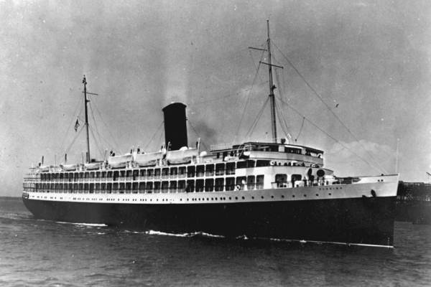
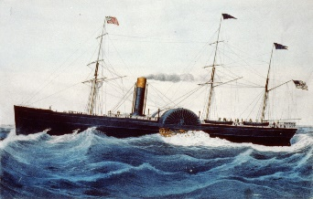

…even in the 2000’s!

*As recently as 2005, 95% of the electricity generated in the U.S.A. was made by steam-powered turbines.
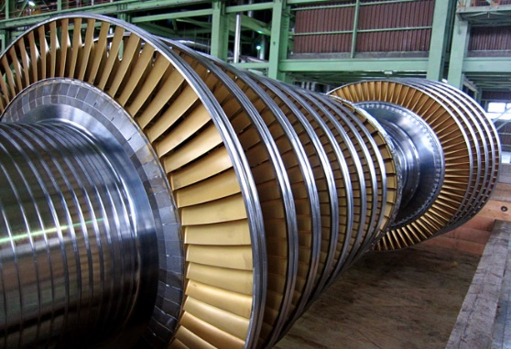

*Today, 95% of nuclear power plants rely on steam engines to work.
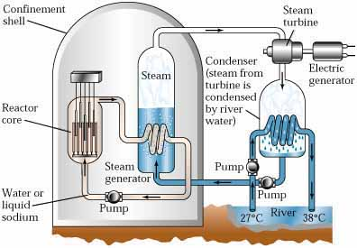

Did You Know?
Interesting Facts About the Steam Engine

1. One of the first steam-powered machines was invented by an ancient Greek named Hero before Year 1 A.D.
2. In the early 1800’s, an English man named Richard Trevithick made one of the first steam-powered locomotives. He charged people about half a week’s salary to see it go around a small oval track- and lots of people paid that price to see it!
3. In 1980, water was heated by magma under Mount St. Helen’s in Washington until the steam exploded. It blew off the top of the mountain!
4. Even today, scientists continue to find uses for steam power. Some spacecraft are powered by steam!

Do you still believe steam is just heated water?

Remember that steam built the industrial world!
